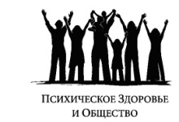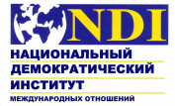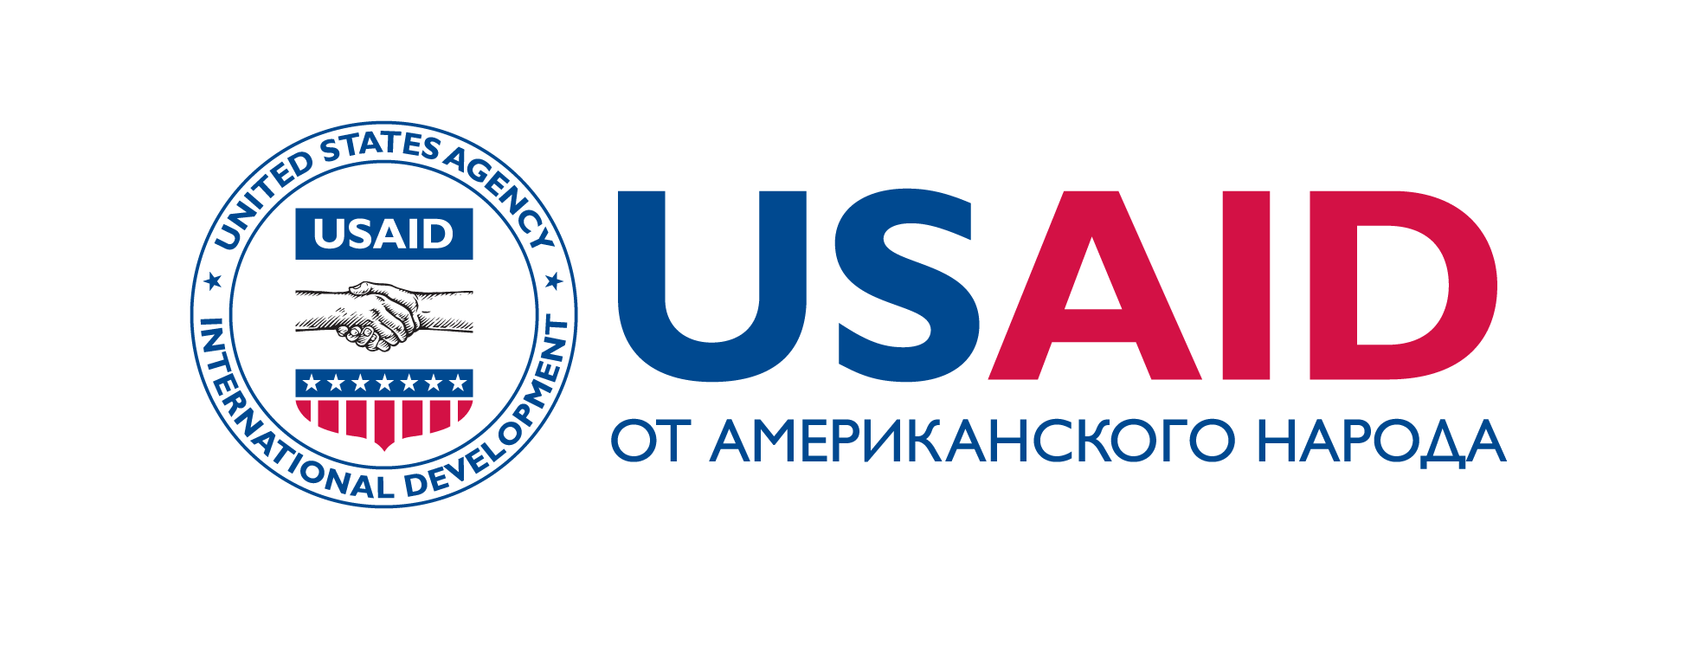

Final report
On Improvement of Communication between Users, Territorial Departments of the Mandatory Health Insurance Fund, Pharmaceutical Businesses, Local Self-Governance Bodies, State Health Care Institutions to Promote Implementation of the State Guarantees Program Project for the Period from May 15 to August 15, 2011

Role of the state oblast administrations in execution of the right for access to life saving medications

Bishkek, 2011

Introduction
Access to life saving medications directly relates to observance of human rights. It specially concerns people with mental disorders, because access to medications enables them to avoid restraint in psychiatric facilities.
In 20005, the Kyrgyz Republic approved the European action plan for protection of mental health, so it assumed responsibility for re-direction of efforts and resources from institutional assistance to assistance on the basis on communities.
However, 87 percent of the health care system budget in the Kyrgyz Republic, allocated for treatment of mental disorders, is still concentrated in isolated gloomy institutions, which are more like the places of detention. Meanwhile, access to medications domiciliary is an indispensable condition for de-institutionalization and the first recommendation of the World Health Organization for reformation of services, related to mental disorders treatment.
Privileged pharmacological support at the outpatient level, developed and introduced by the Mandatory Health Insurance Fund (hereinafter referred to as the MHIF) according to the Program of state guarantees for people with mental disorders, was the first step towards approach of the services on mental health protection to communities. It provided high satisfaction of patients and members of their families and showed high economic efficiency as compared to institutional assistance. At the same time, the problem, related to observance of human rights of people with mental disorders, started to be solved. Solution of this problem enabled people with mental disorders to avoid restraint in psychiatric facilities.
With that, some regions do not fully utilize financial funds, allocated by the state within the framework of the Program of state guarantees. One of the main reasons consists in insufficient participation of state administrations and local self-administration bodies
The present project was aimed at promotion of improvement of communication between state administrations, consumers of services of non-governmental organizations, mass media and pharmaceutical suppliers as well as at increase in the role of state administrations with regard to improvement of medications accessibility.

Methodology
In order to achieve the stated aims and objectives, two forums were arranged in Batken and Talas oblasts: “Access to life saving medications within the framework of the Program of state guarantees”. Relevant researches have been preliminarily performed in these oblasts.
Asel Koilubaeva (the lawyer), sent inquiries to state administrations of seven oblasts with regard to activities of the coordinating commission for management of the health care system.
Ilim Sadykov (the expert), performed analysis of the acting Standard Statute on the Coordinating Commission for management of the health care system in Bishkek and Osh cities as well as oblasts of the Kyrgyz Republic, No.447, dated July 21, 2003.
Davirbek Sadikov (the expert) performed analysis of the regulatory legal acts on authorities of local self-administrations in the sphere of health protection of citizens in the Kyrgyz Republic.
On the basis of results of pharmaceutical forums, analysis of responses to inquiries and analysis of regulatory legal acts, some recommendations were developed.

Content

Analysis of normative legal documents
Resolution No.447 of the Kyrgyz Republic Government, dated July 21, 2003, approved the Standard Statute on the Coordinating Commission for management of the health care system in Bishkek and Osh cities as well as oblasts of the Kyrgyz Republic. According to this Statute, in Bishkek and Osh cities as well as oblasts of the Kyrgyz Republic, the Coordinating Commission (hereinafter referred as the Commission) should be established by the state oblast administrations and municipal administrations as a body, coordinating and controlling activity of the health care system of the relevant region.
Main aim of the Commission consists in coordination of joint actions of the Ministry of Health of the Kyrgyz Republic, oblast state administrations and municipal administrations of Bishkek and Osh cities with regard to management of the health care institutions.

Main objectives of the Commission include:
- development of coordinated activities on management of the health care system in corresponding region;
- provision of operative inter-departmental and inter-regional cooperation;
- monitoring of the Kyrgyz Republic legislation observance in the sphere of health care;
- introduction of reforms and restructuring of the health care institutions;
- monitoring of health indices of the population’s health;

Thus, analysis of the regulatory legal act showed that the Commission’s structure and its authorities give wide range of possibilities for various sectors for cooperation.
The problem consisted in execution of the normative act.
Analysis of inquiries showed that the health care issues are not of high priority for oblast state administrations. Responses were provided by administrations of Chui, Issyk-Kul, Jalal-Abad and Naryn oblasts. Administrations of Batken, Talas and Osh oblast state administrations did not provide any response. The inquiry included the questions about the Commission’s structure, agenda of latest sessions and number of participants. It was determined that the Commission’s sessions were not arranged in some administrations. Commissions were not created in all oblasts.
Individual oblast state administrations do not have clear vision about functional obligations and authorities of the Commission, Special anti-epizootic commission, so functions of the Commission are not distinctly specified.
The issues, related to pharmacological support, are not the object for individual discussion and acceptance of relevant decisions on them. None of the state administrations included the issues, related to access to life saving medications within the framework of the Program of state guarantees, into agenda.
Involvement of local community, public organizations, representatives of pharmaceutical business and other parties concerned into activity of the Commission is quite insufficient.
Analysis of the obtained results and review of forums testify about poor potential of the Commission.
Though role of local self-administration bodies was not included into the project objectives, the analysis of regulatory legal acts was performed with regard to authorities of local self-administrations in the sphere of protection of health of the Kyrgyz Republic citizens. Result of the analysis showed there is a certain discrepancy between the Kyrgyz Republic Law “On local self-administration” and the Kyrgyz Republic Law “On protection of health of the Kyrgyz Republic citizens”. The Kyrgyz Republic Law “On local self-administration” does not contain the objectives, aimed at promotion of the policy in the sphere of health care and inter-departmental and inter-sectorial coordination of the health care issues at the level of local self-administration bodies.

Arrangement of local forums
On June 9, 2011 (Talas city) and June 28, 2011 (Batken city), the Forums “Access to life saving medications within the framework of the Program of state guarantees” were arranged. In both cases, the forums were arranged with the help of departments of health care and social policy of oblast administrations.
All parties concerned, including non-governmental organizations and pharmaceutical suppliers, were invited to participate in the Forum. Since performance of the research in 2010, a considerable progress was observed in Talas oblast in the sphere of increase in competences of the administration with regard to medication packages, provided by the Program of state guarantees. Efficiency and quality of monitoring on the part of the Territorial Department of the Mandatory Health Insurance Fund were improved. Cooperation with mass media and non-governmental organizations also improved. Moreover, random visits to individual aiyl okmotus showed poor information awareness of the population and aiyl keneshes about medicine programs.
All these aspects provide unfair distribution of medications even at availability of certain improvement of medicine programs implementation. Participants of the Forum reached the conclusion about necessity in unification of efforts for provision of transparency of pharmacological support.
In Batken and Talas oblast, the progress was observed in acknowledgment of pharmaceutical suppliers as the partners in socially significant process of implementation of the state medicine programs. Further active involvement of pharmaceutical suppliers as equal partners will reduce corruption in the sphere of medications circulation; unification of efforts will improve access to life saving medications for the poorest layers of the population, living in remote rural regions.
Participants of the Forum emphasized the importance in coordination of health care issues by state administrations, because absence of passports prevents people from participation preferential programs. The most vulnerable groups of the population, including people with mental disorders, do not have passports. I.e. these are the people, who have the least possibilities for acquisition of medications at preferential price. This aspect breaches the fundamental principle of justice in the health care system. Role of the state administrations in solution of this problem is really huge.
Within the framework of the project implementation, the tour for experience exchange between Talas and Batken oblasts was arranged in the period July 5 – July 9, 2011. Akmatov A., head of the health care department of the Batken oblast administration, and Abdisamatov J., expert doctor of the Territorial Department of the Mandatory Health Insurance Fund, visited Talas oblast for investigation of the experience. In their report they specified that there is a considerable difference in geographical remoteness of various human settlements in Talas and Batken oblasts. In Batken, geographical remoteness is higher, which causes higher transportation expenses. This fact should be accounted during development of the budget.
On the other hand, they specified insufficient cooperation with non-governmental organizations and mass media in Batken. Also, it was noted that in Talas Territorial Department of the Mandatory Health Insurance Fund, monitoring of medications and supplementary package is more developed.
Moreover, in Talas oblast, information about the medicine program is regularly distributed by means of mass media. Due to efficient transport provision in Talas, inspection of feldsher-midwife stations and groups of family doctors is arranged twice a year. Information about medicine programs is distributed in governmental institutions and schools. Participants of the tour emphasized efficiency of the experience exchange and expressed readiness to strengthen the role of oblast administration in coordination of the health care issues with regard to pharmacological support in close cooperation with non-governmental organizations.
On July 8, 2011, participants of the tour (Akmatov Aijigit and Joldoshbai Abdisamatov) met with Marat Kaliev, the General Director of the Mandatory Health Insurance Fund, and familiarized themselves with activities of the head office of the Mandatory Health Insurance Fund.

Conclusions
Regulatory and legal framework in the form of the Standard Statute on the Coordinating Commission for management of the health care system in Bishkek and Osh cities as well as oblasts of the Kyrgyz Republic, No.447, dated July 21, 2003, creates sufficient legislative possibility and provides required authorities to state administrations for efficient management of the health care system on corresponding territories, including the issues, related to accessibility of life saving medications.
But, the issues of health care are not of high priority for the oblast state administrations.
The issues, related to pharmacological support, are not the object for individual discussion and acceptance of relevant decisions on them. None of the state administrations included the issues, related to access to life saving medications within the framework of the Program of state guarantees, into agenda.
Involvement of local community, public organizations, representatives of pharmaceutical business and other parties concerned into activity of the Commission is quite insufficient. Some state administrations did not even establish the relevant commissions; work of the commissions is poorly organized; sessions are not arranged regularly; potential of commissions and profile departments is insufficient with regard to the issues of health care.
Meanwhile in order to achieve considerable progress, it is necessary to develop regular and well-established inter-sectorial and inter-departmental communication at the level of state oblast administrations. This is proved by review of medical forums, arranged in Talas and Batken oblasts.
The system of regular meetings with participation of all parties concerned, including non-governmental organizations, mass media and pharmaceutical suppliers will enable to solve many issues on site without additional financial expenses only due to improvement of communication. Such meetings should be arranged by state administrations for provision of inter-sectorial and inter-departmental dialogue; state administration has all statutory powers to do that. In order to improve potential of the profile departments of state administrations, it is efficient to arrange tours for experience exchange and improve cooperation with the state health care institutions.
Local self-administration bodies should better specify their objectives for promotion and implementation of the state policy in the sphere of health care, including the issues of access to life saving medications, and improve their regulatory framework.

Recommendations:
Government of the Kyrgyz Republic, represented by the Vice-Prime Minister on social issues should accept measures for improvement of priority of the health care issues, including the issues of access to life saving medications for state oblast administrations as well as take over the control of the Standard Statute on the Coordinating Commission for management of the health care system in Bishkek and Osh cities as well as oblasts of the Kyrgyz Republic, No.447, dated July 21, 2003.
Local self-administration bodies should better specify their objectives for promotion and implementation of the state policy in the sphere of health care, including the issues of access to life saving medications, and improve their regulatory framework.
Ministry of Health and Mandatory Health Insurance Fund should improve cooperation with the Kyrgyz Republic Government, represented by the Vice-Prime Minister on social issues, oblast state administrations, National Agency for Local Self-Government of the Kyrgyz Republic for promotion and implementation of the state policy in the sphere of health care, including the issues of access to life saving medications, and improve their regulatory framework.
Health Care Committee of the Jogorku Kenesh should achieve consideration of the health care issues in the course of medical forums by the Vice-Prime Minister on social issues, oblast state administrations, oblast state administrations, National Agency for Local Self-Government of the Kyrgyz Republic at least twice a year with participation of non-governmental organizations, mass media and pharmaceutical suppliers.

Director of the Mental Health and Society
Makenbaeva Burul

Budget of the psychiatric public health care: whether the state money flows meet requirements and needs of people with mental disorders? Bishkek, 2009
«Mental health: new understanding, new hope», Report on the health care system in the world. World Health Organization. 2001.
Budget of Mental Healthcare: Do the Public Money Flows Meet the Needs of People with Mental Health Problems? Monitoring Report on Mental Health Budget in the Kyrgyz Republic, 2009. www.mhealth.in.kg
Report «Accessibility of medications for people with mental disorders within the framework of the Program of state guarantees in Batken and Talas oblasts» 2010 www.mhealth.in.kg

